Brief introduction:
This analysis looks at the performance of the GSEMO algorithm across 11 problem instances, ranging across problems such as MaxCoverage, MaxInlfuence, and PackWhileTravel. Each problem instance was run thirty times where each instance ran was 10,000 function evaluations. The plots demonstrate the mean and standard deviation across the 10,000 function evaluations and graphs their performance.

The problem instances are as follows:
- MaxCoverage: 2100, 2101, 2102, 2103
- MaxInfluence: 2200, 2201, 2202, 2203
- PackWhileTravel: 2300, 2301, 2302

Problems 2100s: There is a very obvious trend in the relationship between GSEMO and exercise 1 algorithms.
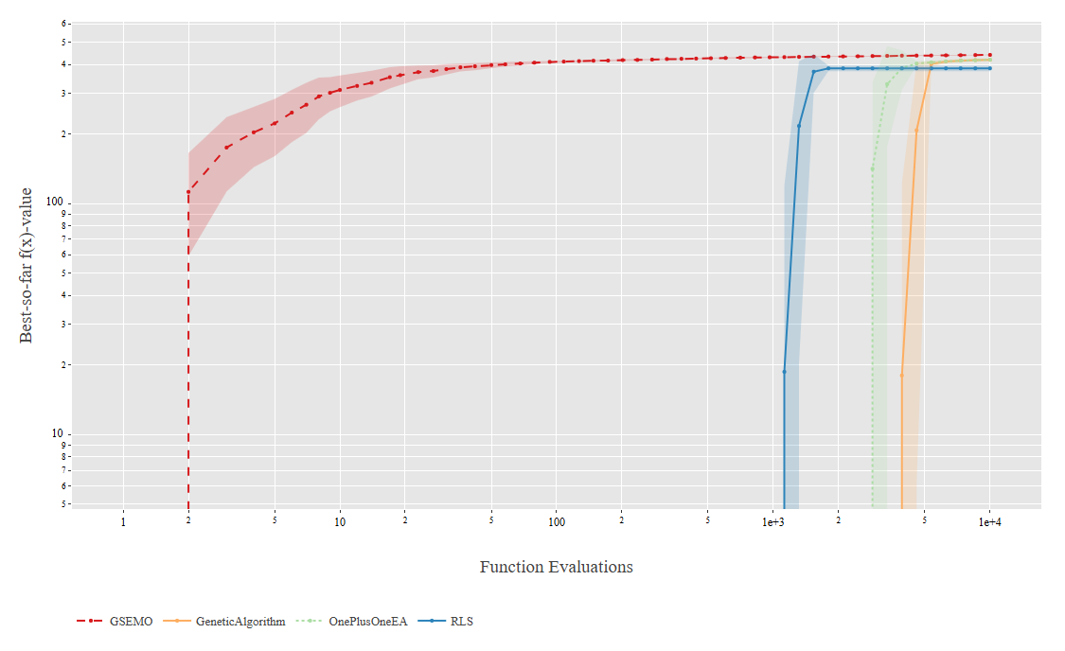
Instance 2100: GSEMO quickly increases during the first evaluations and stats to plateau near its maximum early on way before 10,000 evaluations. It shows way faster convergence than the exercise 1 algorithms. Its shaded region representing standard deviation is rather small which indicates low variance and stable performance. All other algorithms improved later suggesting slower adaptation.

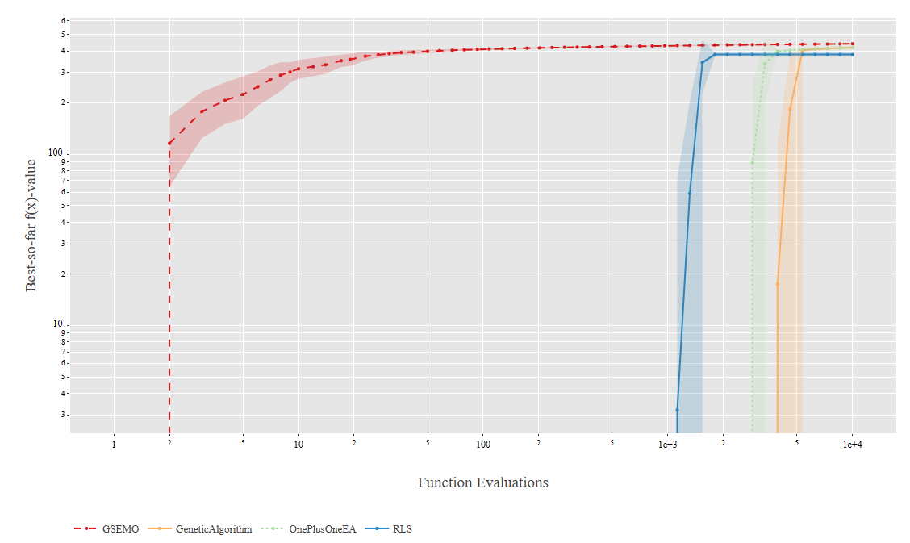Instance 2101: Once again, GSEMO reaches high best value then remains stable, ending with narrow standard deviation. Exercise 1 algorithms reach similar values but requiring more evaluations. The early maxing suggests GSEMO finds good trade-offs efficiently without too much exploration.
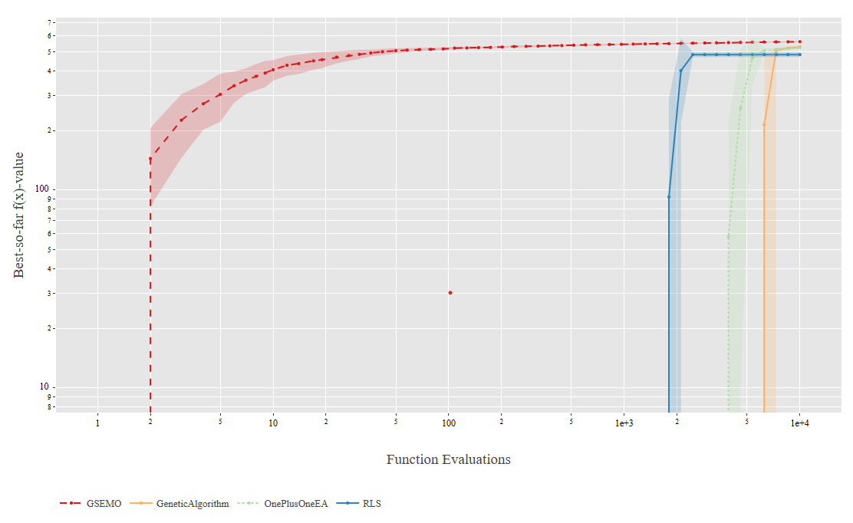 Instance 2102: GSEMO still performs well early, though the curve this time rises a bit more gradually. Variance is a little wider in the early stage but convergence still occurs quickly. The exercise 1 algorithms shows late surges as typical, catching up only near the evaluation limit of 10,000 budgets.
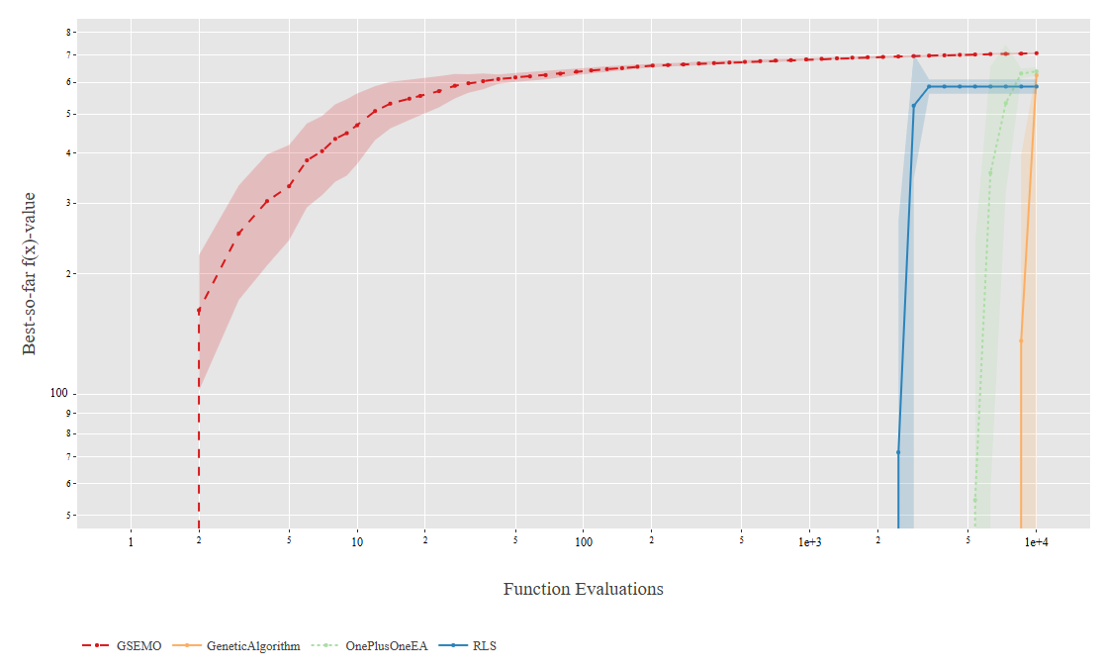
Instance 2103: The trend is very similar. Though the shaded region at the start is much more pronounced, suggesting larger deviation between runs. GSEMO, as expected, achieves the highest plateaued value quickly with low variance as it approaches 10,000 evaluations. Single-objective algorithms still remain slower, showing delayed improvement.
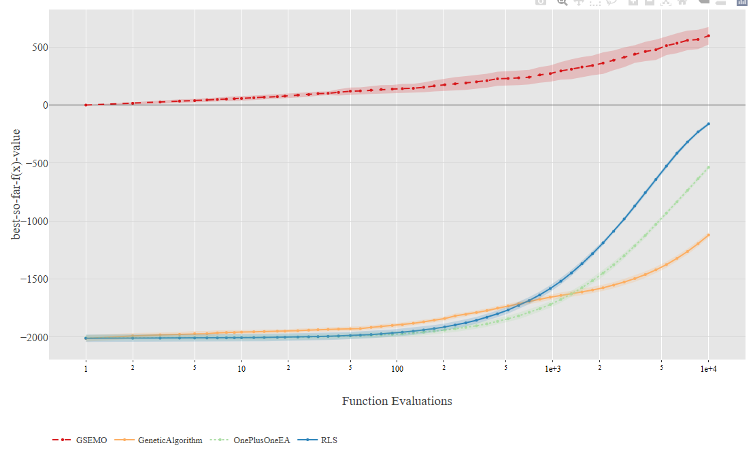
Problems 2200s: GSEMO shows early improvement, higher final performance, and lower variance. All visuals looks similar to each other.

Instance 2200:
GSEMO improves immediately, steadily increasing best value from ~0 to above 500 by the end of the run. Exercise 1 start much lower around -2000 and begin rising after ~10³ evaluations, with RLS improving the fastest. The standard deviation for GSEMO is narrower, indicating low variance and consistent convergence.
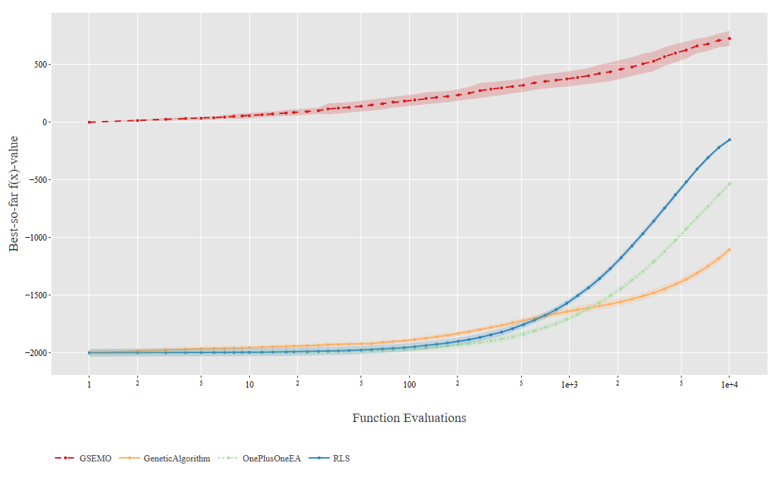
Instance 2201: The trend here is nearly identical to instance 2200, where GSEMO rise smoothly while others lags behind until later. All the growth curves are gradual and steady, indicating continuous improvement, however the exercise 1 algorithms show slower increase. Variance remains small across all, demonstrating stability.

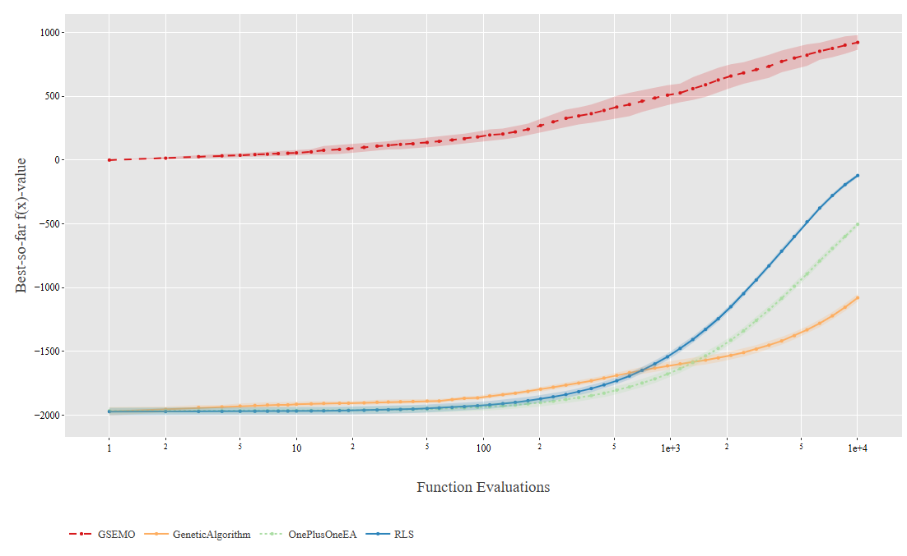
Instance 2202: GSEMO once again dominates, going into positive best values very early. The exercise 1 algorithms remains negative for most of the 10,000 budget. Standard deviation for GESMO is slightly wider which suggests some variation between runs. However, performance is far more consistent than RLS, EA, and GA, which converges slower.
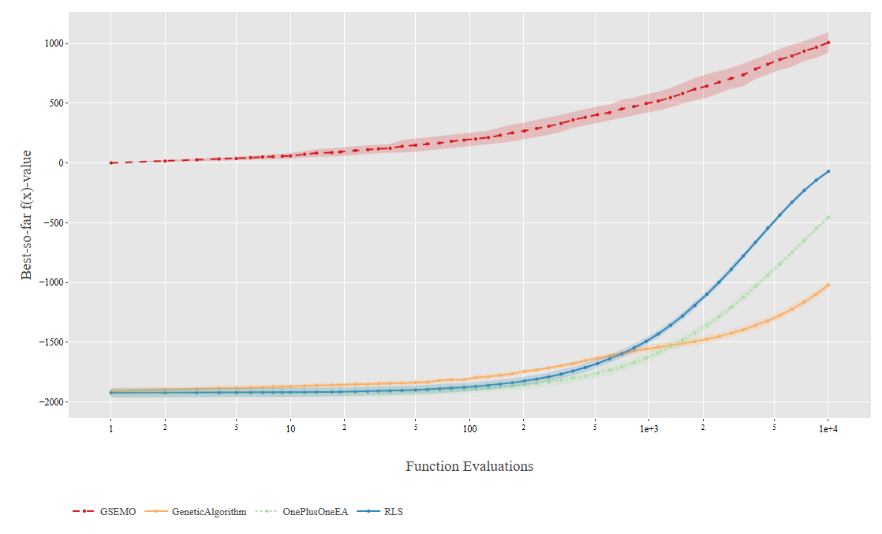
Instance 2203: GSEMO moves forward with its upward trend, reaching fitness value of 1000, outperforming all other algorithms. Exercise 1 algorithms still improves slowly but never ends up with positive fitness values within budget of 10,000. Variance is small, confirming that GSEMO is reliable at finding strong solutions.
Problems 2300s: across all 2300 problems, GSEMO converges quickly but start struggling, exercise 1 algorithms starts showing advantage.
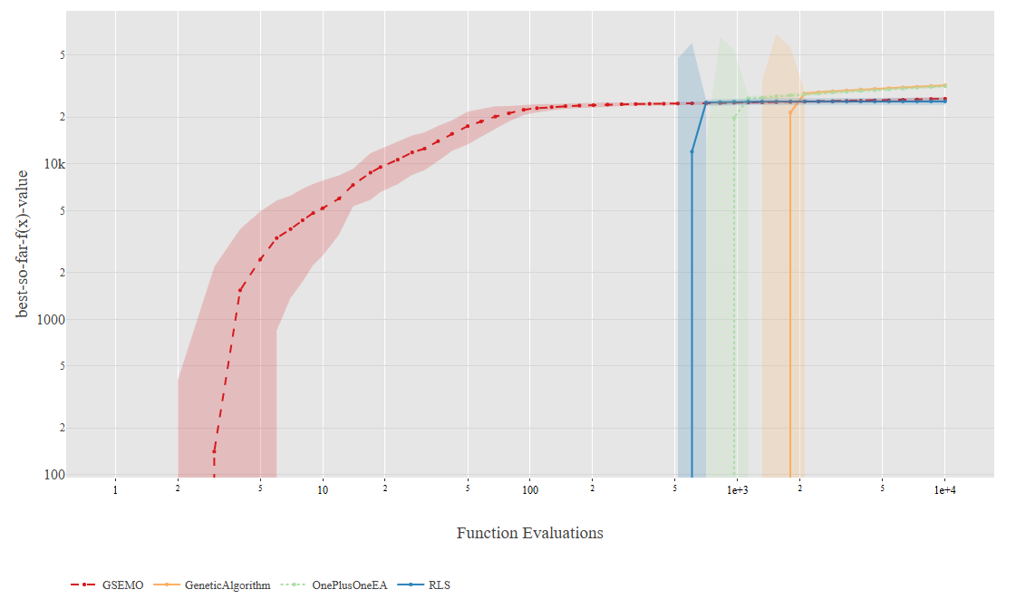
Instance 2300: GSEMO improved extremely quickly early stage, until ~10⁴ mark. The variance band is wide in the early phase, indicating instability but it narrows once convergence occurs. Exercise 1 algorithms rises later, and all four algorithms eventually match similar fitness levels near the end.
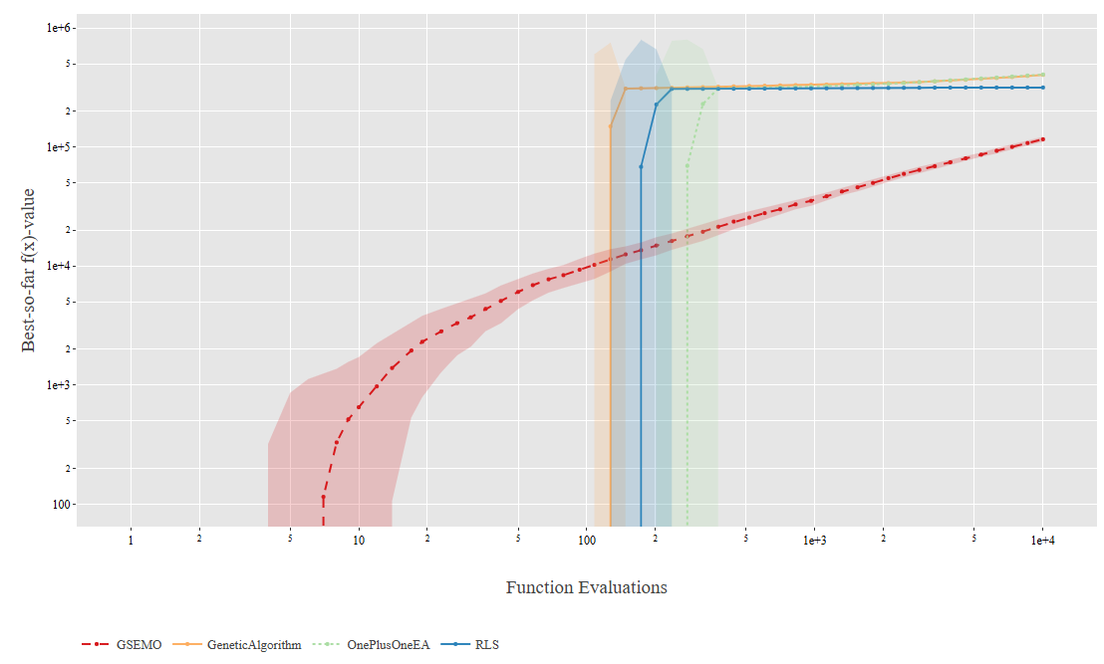
Instance 2301: GSEMO shows early growth and maintains a very steady growth until the end. Its shaded region is still larger, demonstrating variability in early exploration. Convergence never occurs before 10,000 evaluations. Exercise 1 algorithms shoots up after ~100 evaluations and overtakes GESMO.
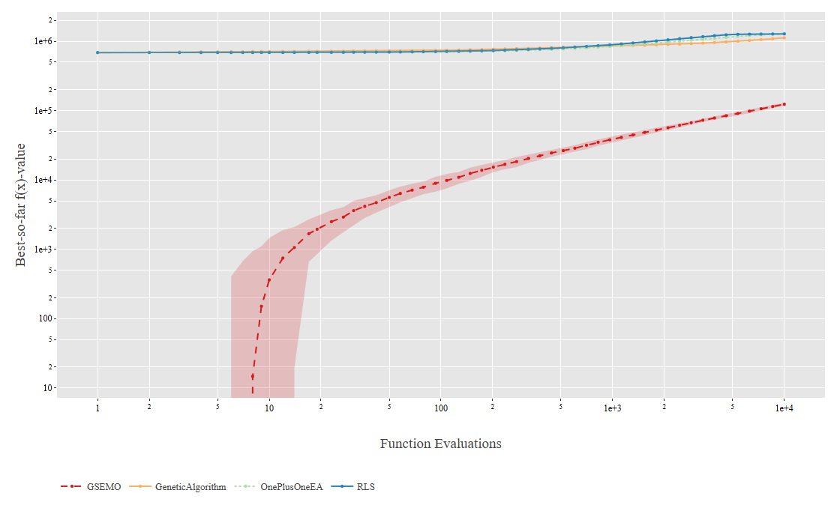
Instance 2302: GSEMO shoes slow progress and achieves lower fitness than the other algorithms. With its wide variance band, GESMO has inconsistent performance across runs and potential difficulty adapting to this instance’s landscape. Exercise 1 algorithms reaches plateau early on and remains stable.
Final Summary:
In summary, GESMO algorithm implemented for exercise 2 dominated the single objective algorithms developed in exercise 1 in most cases, as indicated by low variance early convergence and high stability after convergence. However, it potentially had difficulty adapting to instance 2300s (PackWhileTravel) as it remained disadvantaged, with single-objective algorithms outperforming it for two out of three cases.

